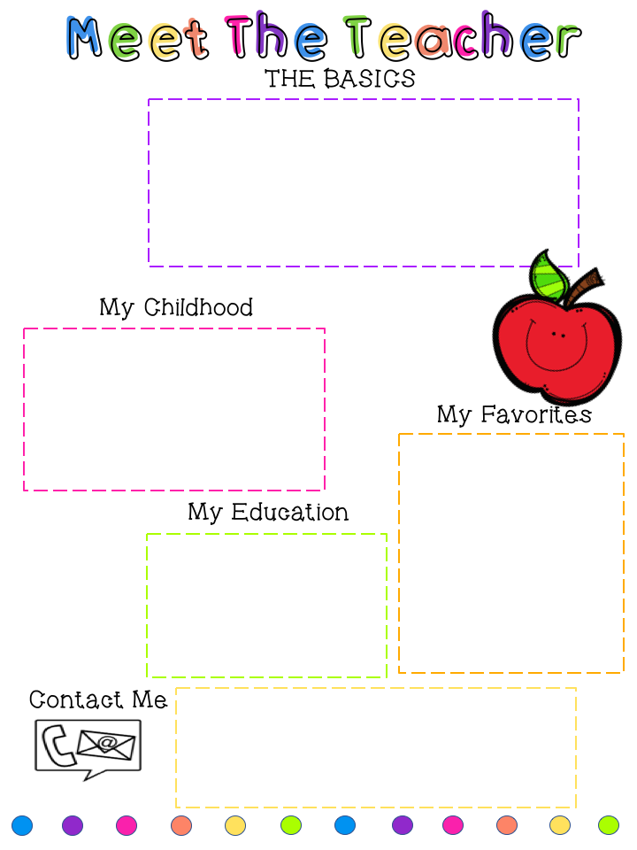

Authors: Mo Willems and RoAld Dahl

Foods: Seafood and Thai

Subjects: Math and Reading

Season: Summer

Holiday: Christmas

[Ellen.trinity@slps.org](mailto:Ellen.trinity@slps.org)

[ellentrinity@yahoo.com](mailto:ellentrinity@yahoo.com)

(314)353-8875 (314) 667-9196 C



Madeline is 23

Gwen is 17

Our Dog Charlie

* Bachelor of Science from SIUE
* Masters in Gifted Education
* Certified in Gifted Education



Ellen Trinity

Second Grade Teacher

Betty Wheeler CJA

[Ellen.trinity@slps.org](mailto:Ellen.trinity@slps.org)

 M

My Family

